UNIVERSITY OF DAR ES SALAAM



COLLEGE OF INFORMATION AND COMMUNICATION TECHNOLOGIES (CoICT).

DEPARTMENT OF ELECTRONICS AND TELECOMMUNICATION ENGINEERING.

ES 499: FINAL YEAR PROJECT

PROGRESS REPORT

|  |  |
| --- | --- |
| PROJECT TITTLE: | SECURED WIRELESS USB FLASH DRIVE. |
| STUDENT`S NAME: | KOWERO, WALIDI WAZIRI |
| REG. NO: | 2020-04-04390 |
| PROGRAM: | BSc. IN ELECTRONICS ENGINEERING |
| SUPERVISOR`S NAME: | PROF BARAKA MAISELI. |
| SUPERVISOR’S SIGNATURE: | ……………………………. |
| STUDENT’S SIGNATURE: | ……………………………. |
| SUBMISSION DATE: | 19th, MAY 2023 |

# ABSTRACT

This project aims at utilizing this advancement in technology that we have achieved so far to develop a secured wireless system that can perform seamless data transfer to the client over different operating systems. The system tries to increase the mobility and freedom and provide more options to the user towards the access of information.

TABLE OF CONTENTS

ABSTRACT i

LIST OF FIGURES iii

LIST OF ABBREVIATIONS iv

CHAPTER ONE 1

INTRODUCTION 1

Background 1

PROBLEM STATEMENT 3

OBJECTIVES 3

Main objective 3

Specific Objectives 3

LITERATURE REVIEW 3

METHODOLOGY 5

Concept Generation 8

Block Diagram 8

Flowchart 9

Use Case 12

Relation Diagram 14

Sequence Diagram 14

EXPERIMENTATION 15

PROGRESS 16

CHALLENGES 23

TIME SCHEDULE 24

BUDGET 24

REFERENCES 26

# LIST OF FIGURES

Figure 1 Basic Scheme of a semiconductor memory cell 1

Figure 2 A typical USB Flash Drive 6

Figure 3. A modified Block diagram of a system 9

Figure 4 The main program workflow 10

Figure 5. Samba Server Flowchart 11

Figure 6. Web Server Flowchart 12

Figure 7. Use Case 13

Figure 8. Entity relation diagram 14

Figure 9. Sequence diagram 15

Figure 10. Simulation on wokwi. SD card is used in place of Nand Flash memory to demonstrate non-volatile file storage. 17

Figure 11.Interactive Web file server as output after simulation 17

Figure 12.Experimented circuit on the board 18

Figure 13.Experimented circuit is visible as a usable flash ready to format for general uses 19

Figure 14. Present user interface. User is automatically redirected to this page connected to this device’s Wi-Fi. Like TTCL-WIFI 2 and WIFI 4U. 20

Figure 15. Schematic design of the prepared circuit 21

Figure 16. Prepared PCB layout 22

Figure 17. 3D layout of the prototype 22

Figure 18.Time Schedule 24

# LIST OF ABBREVIATIONS

|  |  |
| --- | --- |
| **Abbreviation** | **Long form/meaning** |
| CUWB | Ciholas Ultra-wideband |
| eMMC | Embedded Multimedia card |
| SMB | Server Message Block |
| NAS | Network attached Storage |
| NFS | Network File system |
| PCB | Printed Circuit Board |
| USB | Universal Serial Bus |
| UWB | Ultra-wideband |
| Wi-Fi | Wireless Fidelity |

# CHAPTER ONE

## INTRODUCTION

### Background

Majority of the storage technology have been largely improved in term of speed, capacity and reliability over the past 20 years. Some of the major discovery include

* discovery of Magnetic tape (1930) which uses a plastic tape containing magnetic material which creates a certain pattern of potential difference when passed through magnetic sensor. This pattern is the data stored in the tape (Bogart, 1995),
* discovery of Magnetic disk drive (1956) which uses a metallic circular disk with magnetic property rotating with high speed whereas data is stored within each circumference in the disk. The magnetic sensor then is placed with displacement of a varying disk radius to read the data. This data I is then analyzed to information [2] and
* discovery of semiconductor memory cell (1967) which uses a floating gate technology to store data in form of charging a capacitor where by the electrons a trapped within the floating layer (Bogart, 1995).

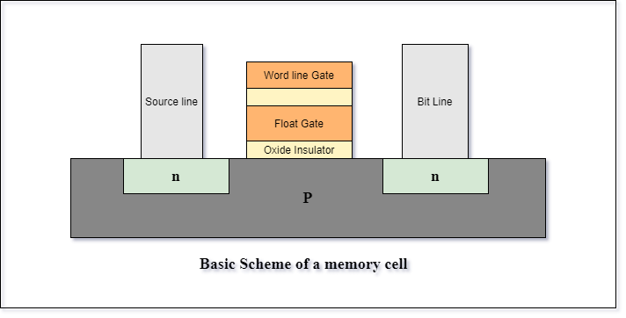

Figure 1 Basic Scheme of a semiconductor memory cell

This discovery has then led to two major discoveries based on the configuration involved:

1. Nand Memory: whereby the memory device is formed by parallel arrangement of semiconductor memory cells while
2. Nor Memory are formed by a serial arrangement of semiconductor memory cells

(Hyperstone, 2020)

In the current world as far as the current technology is concerned, there have been a lot of advancement of storage technologies. Since the early 2000s, as the microelectronics world rapidly changes from small scale integration to very large integration, the technology of storages has been simultaneously increasing toward higher scale of integration.

This increase in technology has allowed vasty increase in storage capacity over the time from several kilobytes that was stored in floppy disks and tapes to several Terabytes that can be stored in hard disks drives and solid-state drive.

Most of devices in the present time usually stores up to several gigabytes that can achieve up to 600 megabytes per second for reading and writing speed. These devices can be used for storage, data transfer or booting process.

Development of portable disk drives like USB flash drive, portable external hard disks and compact disks has been increasingly adopted over the years which lead to increasingly large number of flash disks in the market which does not satisfy the actual needs of the local market like compatibility, storage, costs and durability.

Furthermore, the increase adoption of the wireless radio communications protocols like Wi-Fi and Bluetooth has led to increase in reliability and flexibility to access data seamlessly over many applications like IoT systems, automation systems as well as industrial systems.

These wireless communications protocols have been used so far to transfer data and information over the internet and other subnetworks whereby some can even achieve up to 900 megabytes per second.

This project aims at reviewing and implement wireless storage system to the local market by using Nand memory since it is cheaper than the nor memory based on the research results done at the previous practical training.

The main stakeholders for this project are the local market of Tanzania.

## PROBLEM STATEMENT

"In the realm of data storage, there's a growing demand for enhanced flexibility and seamless file sharing capabilities. While current solutions offer commendable features like high data transfer rates and security measures, there's an opportunity to innovate further.

As people’s demand continue to grow, we will only be able to meet their demands through developing a flexible, robust, and secure, wireless alternatives that priorities user friendliness interfaces and a strong data management. This entails developing solutions which not only provide simplicity and compatibility but also increase flexibility and security standards, so that individuals and businesses can enjoy a high quality of experience."

## OBJECTIVES

### Main objective

To enhance flexibility and security in wireless flash storage devices.

Specific Objectives

1. To enable reliable wireless data transfer: by enabling data transfer and access with both physical and wireless connections. In this term portability and convenience are considered.
2. To implement secure ways of data transfer: To implement robust security measures to ensure data is protected during transfer.
3. To implement multipoint user-friendly interfaces: To develop an intuitive and user-friendly interface that can cope with at least more than 3 operating systems with windows and Linux included.

## LITERATURE REVIEW

This project’s literature review is categorized based on the findings and topics. The classification is as follows

* Storage technologies:

1. Nand Memory technology: Based on the article published by Hyperstone on non-volatile memory, The author tries to explain theory behind the existence of NAND flash memory, characteristics, properties and different level of complexity they can achieve in term levels. (Hyperstone, 2020)
2. USB Mass storage server: in the article the author has successfully create and implement a smart usb flash drive using Raspberry Pi zero. The Pi zero acts as usb host and can be accessed wirelessly through SSH or Wi-Fi. The user can use these interfaces to manage files in the Pi zero. (Barnes, 2017)

* Wi-Fi technology:

From an article “For Wireless USB, the Future Starts Now”. The author has tried to explain the emergency of wireless USB which can be implemented over the internet. This rising technology implements the use of current advancement of radio communication and Wi-Fi protocol as the major tools. He also explained different protocols such as UWB, WUSB and CWUSB.

By utilizing the full spectrum, UWB can achieve superior performance while consuming less energy. Essentially, UWB achieves bandwidth by using low-energy pulses across a wide frequency range. The majority of other wireless technologies accomplish performance at the expense of excessive energy consumption since they only use one designated band within a frequency spectrum. (IEEE, 2007)

* Interface used:

1. This design aimed at implementing a storage device that can be accessed wirelessly though acting as a normal USB disk. The design is comprised of two separates modules, the adapter module for the interface to the PC and the storage module, which is made up of the flash memory, chip to be used as a mass storage device. These modules communicate wirelessly for as near as two meters. In this design there is no middleware needed for file transfer. Since the USB module act as a dongle, the computer treats the whole system a separate usb flash drive. (Czapor, Hartney , & Knight , 2006)
2. On another article presenting Sandisk Connect in which the designer has used middleware to transfer data across different operating system. Sandisk wireless pen drive can transfer data in both physical channel through USB and wireless channel through Wi-Fi interfaced to specified Sandisk software for file transfer. Although the product has now been in production decline since 2022 (Digital, 2022)

## METHODOLOGY

This project will follow the water-fall methodology whereas the bottom-up approach will be used to achieve the main objective. This system combines and adopts the works of other successfully works as sub modules or components responsible to accomplish a certain functionality which is then integrated to one system. The following are the key points that will be implemented to accomplish main objective of this project:

* To implementing mass storage server using the normal physical connection that is usb which will provide a user with choices that mostly fits comfortability. This is done by finishing up and utilize the existing design of flash disk drive that uses USB connector that was done as practical training III year 2023 that was done by myself with my colleague Neria I Rutashobya with registration number 2020-04-10739 as the base design for this project

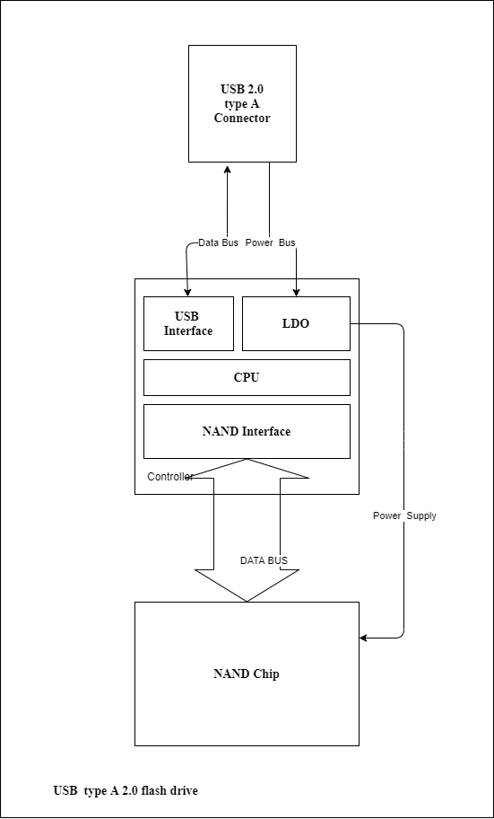

Figure 2 A typical USB Flash Drive

* To develop or utilizing the existing ways of creating a local area network wirelessly between the Host and the Client that involves the user with less handshaking process.
* To develop a robust way of data transfer between the host and the client which include using more than one data channels, modified session database to always remember session whenever there is a fluctuation/loss in connectivity.
* By utilizing the existing encryption technologies such as hybrid encryption technology which utilizes both symmetric and asymmetric encryption technology. A secured and a robust yet reliable system can be developed.
* By implement the in-built features for wireless file transfer that already exist in most of the operating systems like samba (SMB) protocol and network file sharing (NFS) protocol to reduce congestion of procedure that the user is supposed to consider in order to perform data transfer.
* By implementing a user-friendly encasing design, can provide user with a comfortability and enhanced mobility.

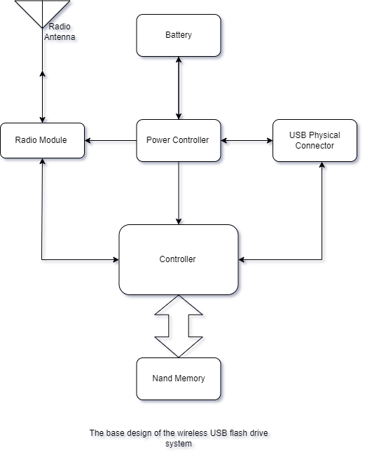

### Concept Generation

The following is a brief journey on how device and tools selection criteria was performed

First, the device systems are listed in term of their percentage to the whole project. In this case, I had six subsystem which are server, controller, Power system, Usb interface, Non-volatile Memory.

Second, for each subsystem available options were listed. The following is the table showing listed systems, available options and optimized final option

|  |  |  |  |
| --- | --- | --- | --- |
| S/N | Subsystem | Available Options | Optimized Final Option |
| 1 | Controller | ESP32, ESP82, STM32, ATMEL Series, PIC, SAMD Series | ESP32-WROVER-1E-N4R8 |
| 2 | File Sharing Server | NFS, iSCs, SMB and Apple File Protocol | SMB |
| 3 | Non-volatile  Memory | SD CARD, eMMC, NAND, NOR and UFS | NAND |
| 4 | USB interface | USB 3.0, USB 2.0, USB 1.1 | USB 2.0 |
| 5 | Power Supply System | Solar powered, Usb powered, Usb powered + battery based, rechargeable battery and non-rechargeable battery | Not decided yet, due to power calibration and uncertainty on the final product |

Third, by using concept generation such as concept table, concept fans and weight matrix options were weighted and unoptimized option were filtered until the suitable option is obtained.

### Block Diagram

Therefore, by adopting the above changes, the total system design is now according to the following diagram with exclusion of power supply subsystem

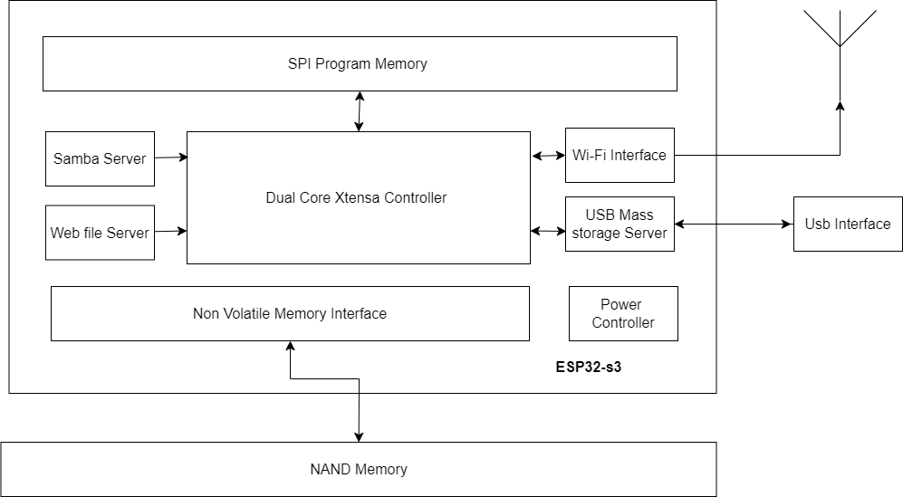

Figure 3. A modified Block diagram of a system

### Flowchart

The projects main process will be implemented through the following trends of processes

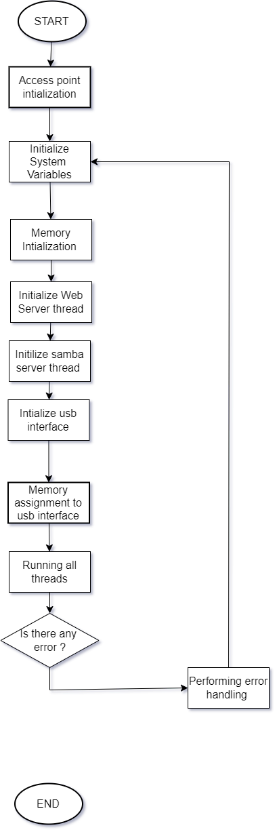

Figure 4 The main program workflow

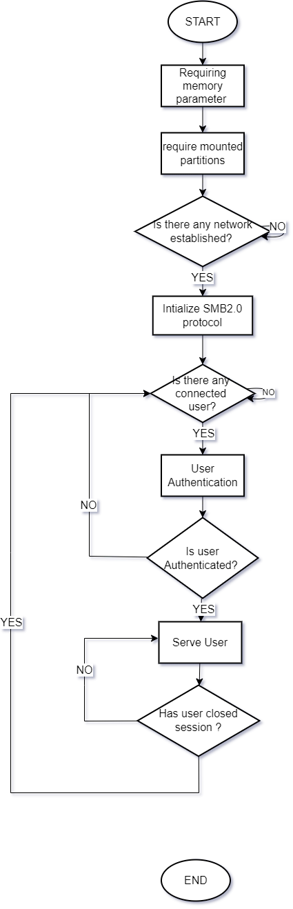

Figure 5. Samba Server Flowchart

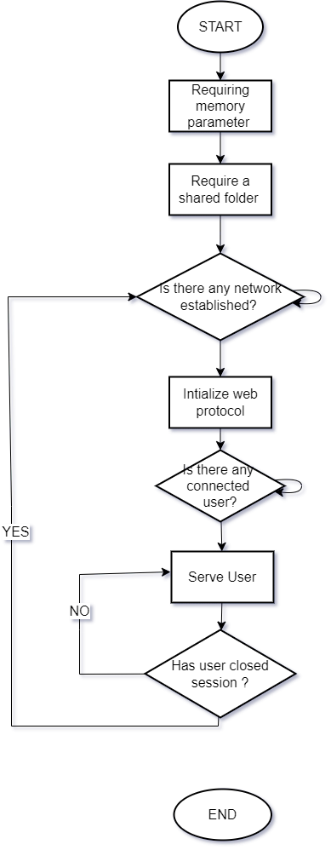

Figure 6. Web Server Flowchart

### Use Case

The diagram below shows on how the user events and processes are initiated and completed in order to achieve the main goal of this project

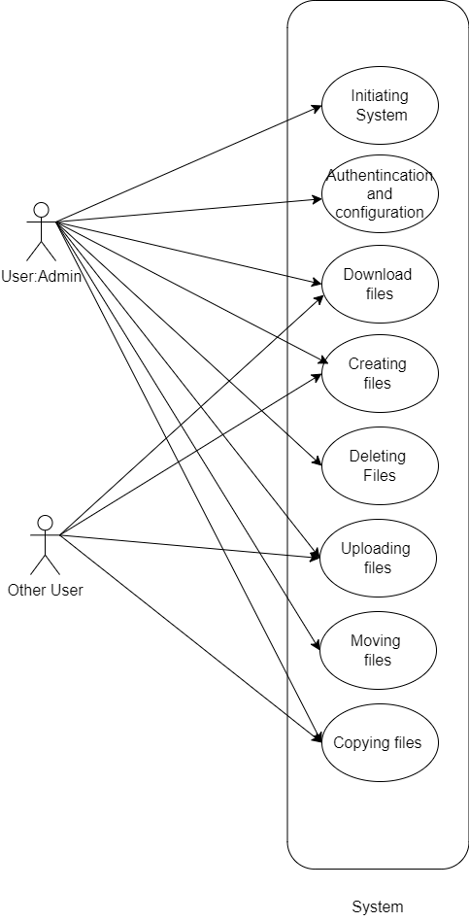

Figure 7. Use Case

### Relation Diagram

In this project there are three important classes which needs to be implemented that is server, storage, and users.

The diagram below shows the relation between each class.

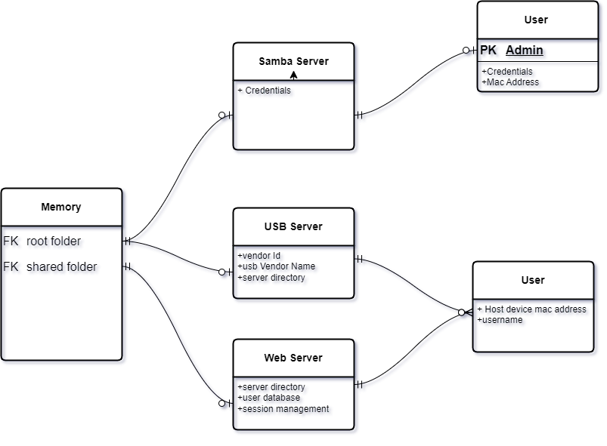

Figure 8. Entity relation diagram

### Sequence Diagram

After definition of the above flow of procedure the sequence diagram between the user and device can be figured as follows

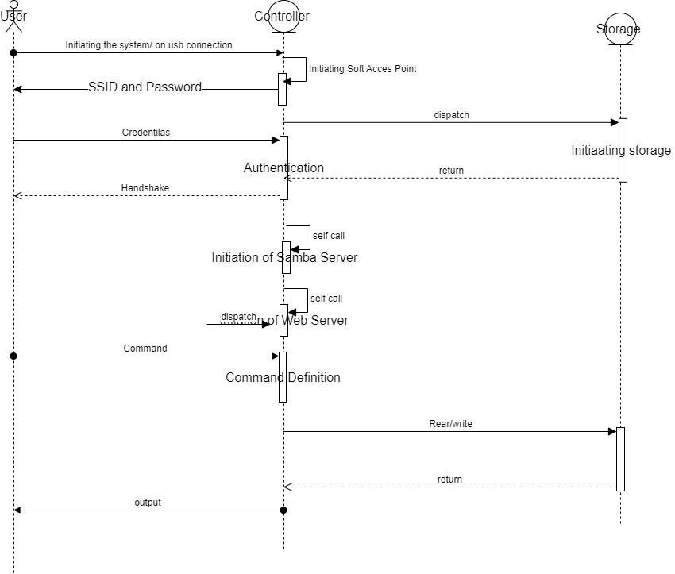

Figure 9. Sequence diagram

## EXPERIMENTATION

Experimentation on the proposed methodologies took two paths. One to which involved Simulation and one to which does not support simulation.

Simulation method:

In this part, the simulation was performed on wokwi and then due to the limited resources could not simulate any further.

Observation:

1. So easy to program and use.
2. It has had a large library hence it is easy to troubleshoot and debug a problem
3. No Wi-Fi interactivity
4. No Nand memory device was available.
5. Requires internet access always.
6. Due to limited interactions, I couldn’t observe my progress

Non-simulation Method:

This method involved systematic preparation of tools and utility like internet, libraries and documentations that could help the achievement of this project’s objectives.

Throughout the journey, the following were performed

1. Programming and testing:

Due to lack of documentations, and references most of the parts were performed from the scratch including parallel NAND flash interfacing which includes its own protocol, Wi-Fi for enterprise level and web file server interfacing.

1. Observation:

Due to the limited microcontroller capability and limited resources the samba server may enquire scope extension for its completion due to high stack memory consumption.

 A single smb server will use 2.6 MB for program and shared libraries, plus 768KB for each single user which is extremely high for microcontroller esp32s3.

### PROGRESS

#### Work done so far

1. Online ordering ESP32S3N16R8 development module, for 35ksh only as the main part of the wireless usb flash drive which was delivered after 2.5 week.
2. Simulating web server on wokwi. This involved making of an asynchronous webserver in esp32s3.

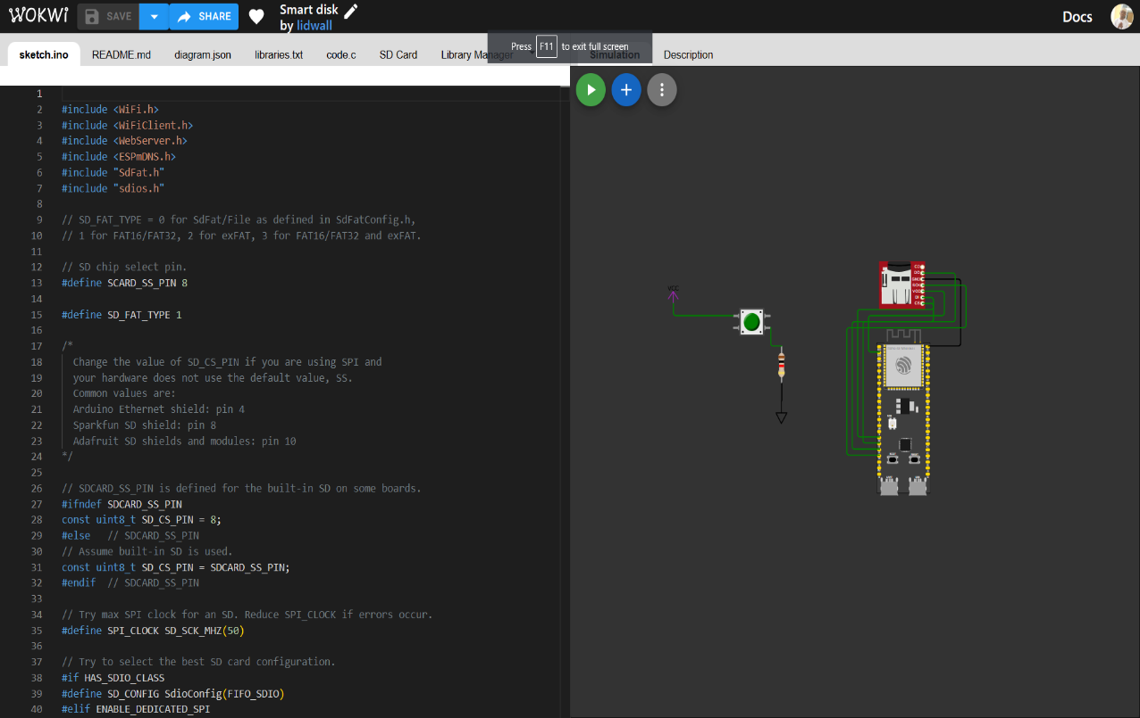

Figure 10. Simulation on wokwi. SD card is used in place of Nand Flash memory to demonstrate non-volatile file storage.

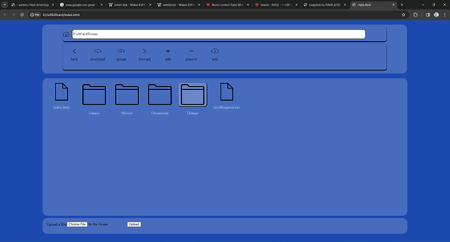

Figure 11.Interactive Web file server as output after simulation

1. Preparing library (‘nandflashReader.h ‘) for reading parallel NAND mt29f16g08ababa using esp32 gpio. This includes programming the timing for reading, writing and managing pages and blocks in Nand flash memory.
2. General implementation of USB Mass storage Server using SD Card as a flash memory.
3. Linking Nand and usb Mass Storage to work as flash drive using esp32s3.

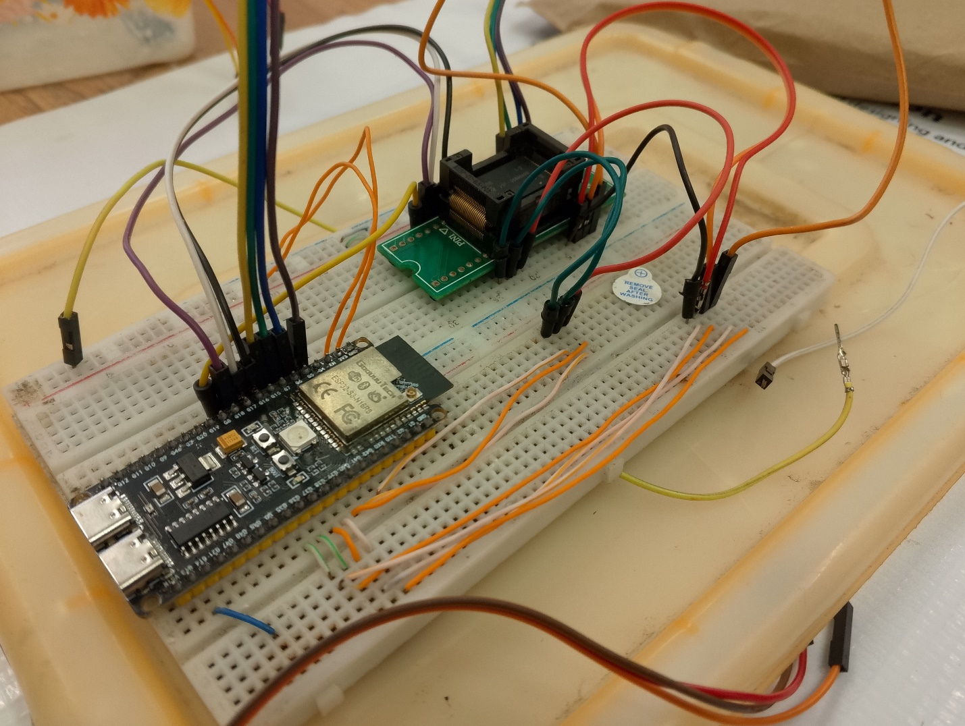

Figure 12.Experimented circuit on the board

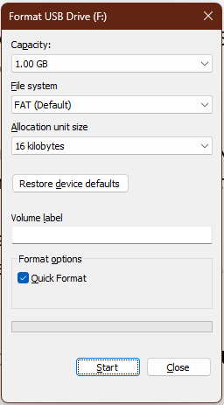

Figure 13.Experimented circuit is visible as a usable flash ready to format for general uses

#### What is being implemented

1. Creating a more User-friendly Interface for configuration using captive portal.

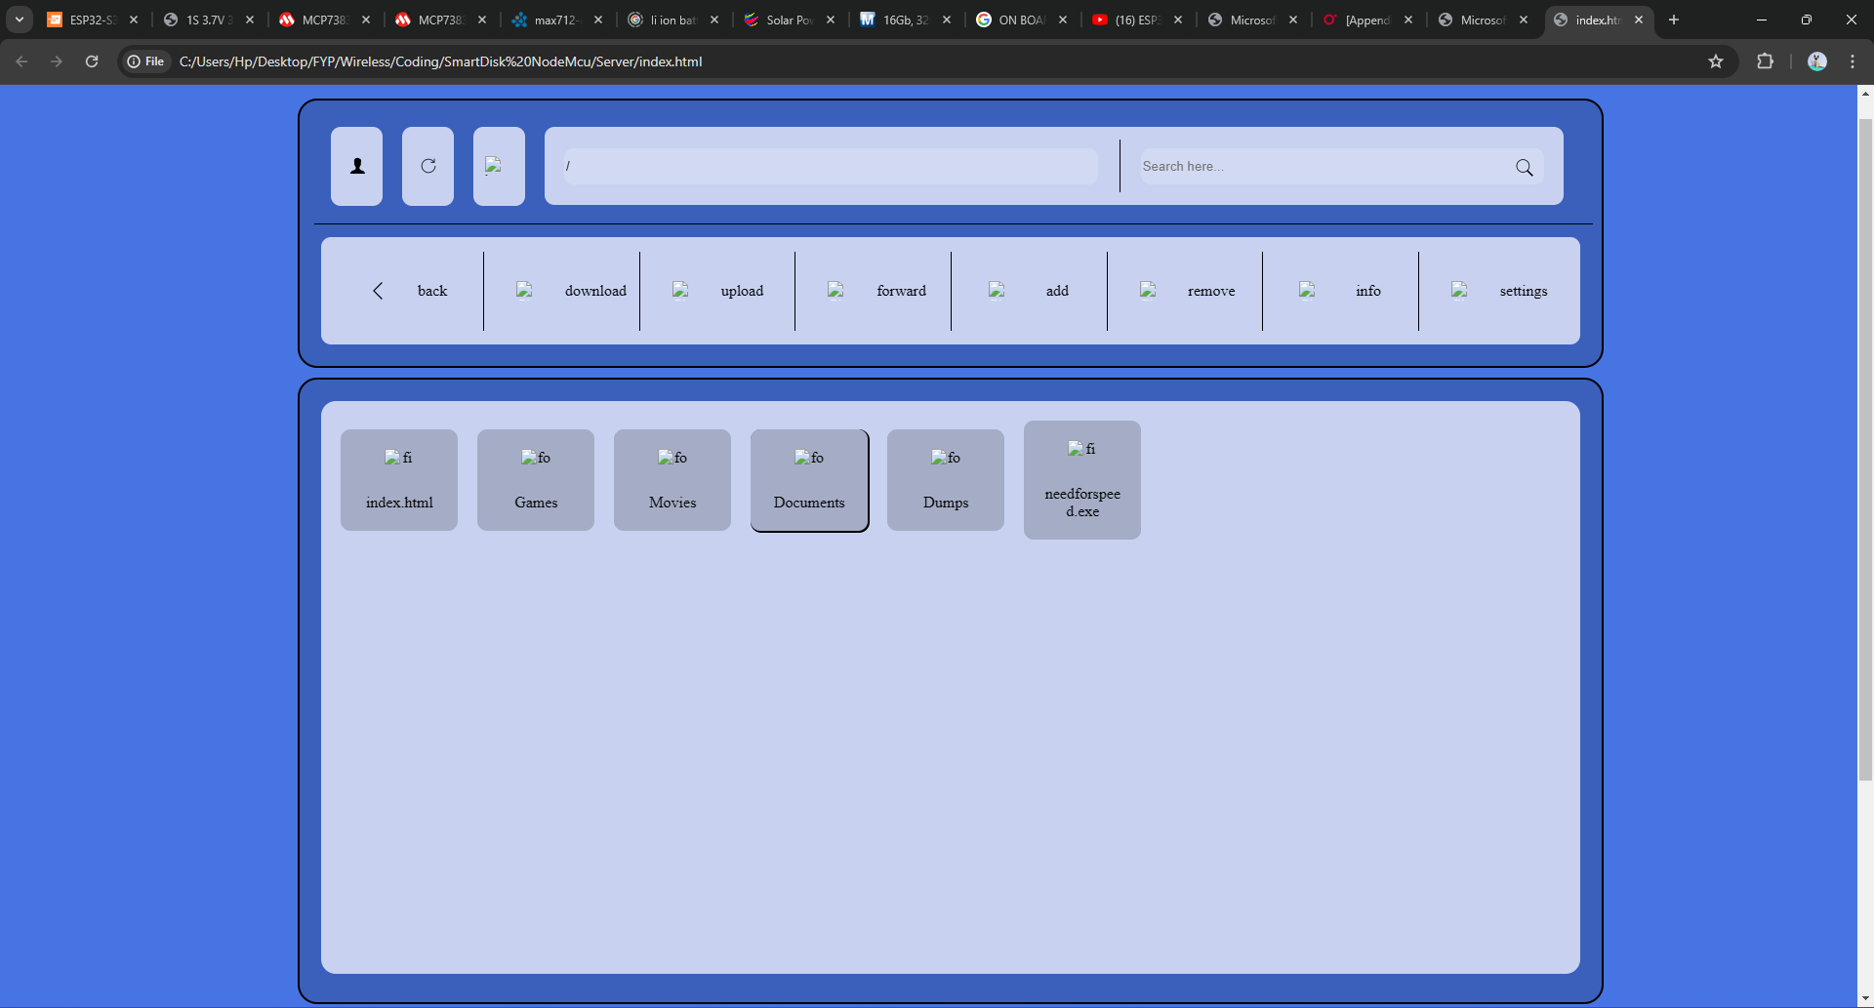

Figure 14. Present user interface. User is automatically redirected to this page connected to this device’s Wi-Fi. Like TTCL-WIFI 2 and WIFI 4U.

1. Preparing and designing schematic and on a Printed Circuit Board (PCB)

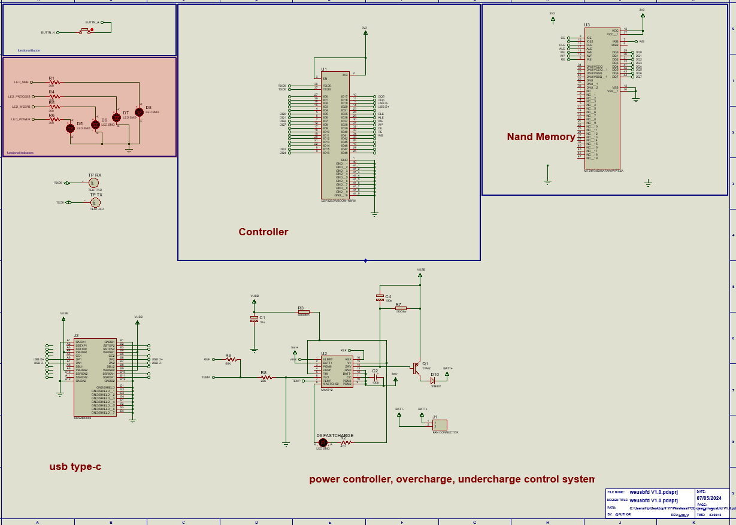

Figure 15. Schematic design of the prepared circuit

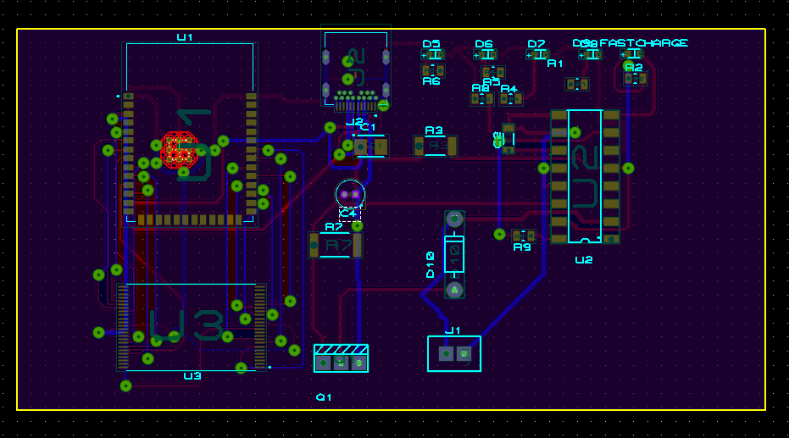

Figure 16. Prepared PCB layout

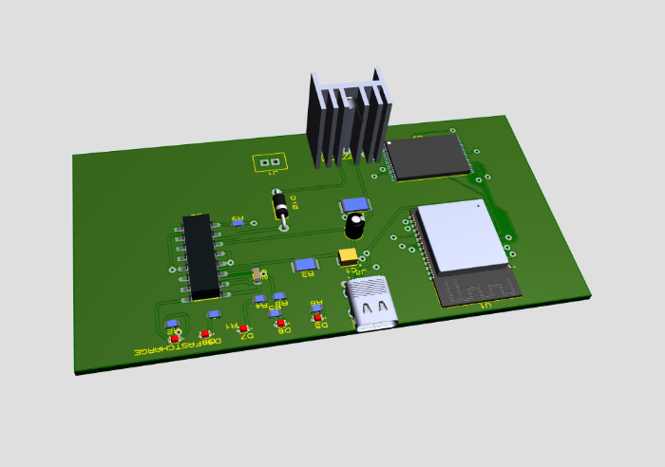

Figure 17. 3D layout of the prototype

#### What is to be done

1. To optimize the usb flash drive speed to reach the commercial usage and requirement.

3. To design 3D encasing for the system.

## CHALLENGES

Despite the minor challenges, major challenges I was facing during implementation of project was

1. Documentation. Since most of the documentation and resources are online there was a challenge in increasing the budget due to increased demands on resources.
2. Low community. Despite using Arduino with large community such complexity of this project led to low support from other members.
3. Utilities, due to the demand of this project is high, most of the utilities like esp32s3 where unavailable in the local market hence led to waste of time during delivery
4. In spite of being able to utilize maximum frequency of es32s3 of about 240MHz the microcontroller still does not provide the expected results as 40MHz for GPIO switch frequency and can only provide 26MHz only.

## TIME SCHEDULE

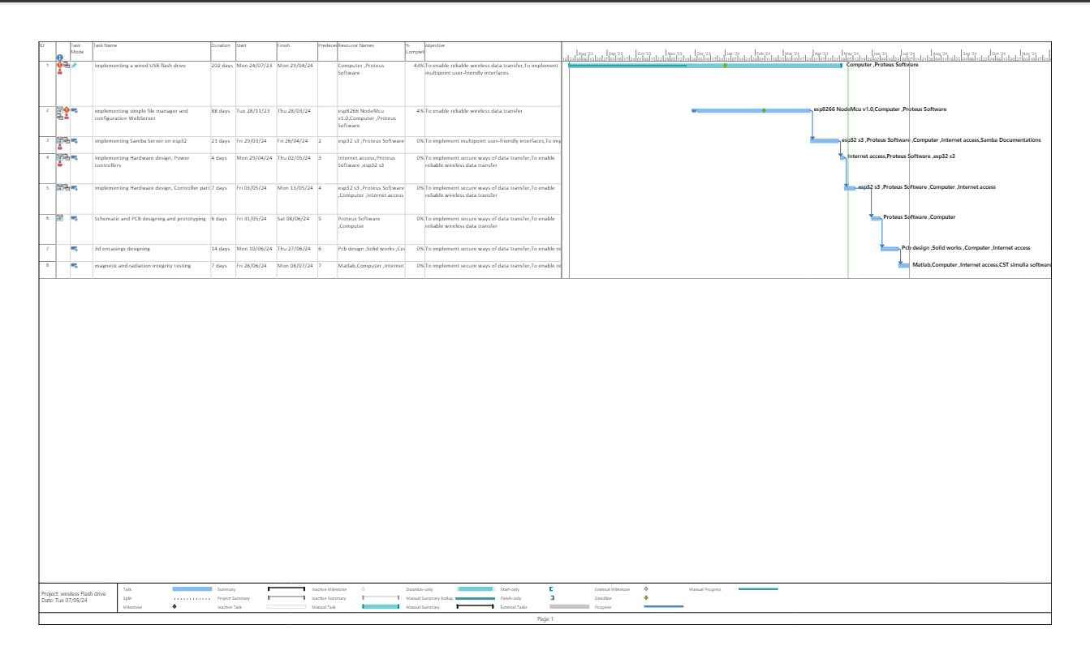

Figure 18.Time Schedule

## BUDGET

This table comprise of the cost that are expected to be used as per initial design and may change due to change in scope

|  |  |
| --- | --- |
| Components | Cost (Tsh) |
| Esp8266 nodeMcu module | 20,000/= |
| Memory card | 10,000/= |
| Memory card module | 8,000/= |
| Esp32 s3 | 45,000/= |
| Breadboard | 15,000/= |
| Lithium-ion Battery | 20,000/= |
| Battery controller (MP2731) | 5,000/= |
| Nand memory storage chip | 5,000/= |
| Connecting wires | 10,000/= |
| USB connector | 1,000/= |
| Internet Access | 120,000/= |
| 3D encasing | 800,000/= |
| Nand flash Memory | 20,000/= |
| Total | 359000/= |

# REFERENCES

al, J. W. (2016). A Survey of Mobile Storage Systems: Flash Drives, SD Cards, and Wireless Flash Drives .

Barnes, R. (2017). Make a Pi Zero W Smart USB flash drive. The MadPi Magazine.

Bez, R. (2004). Non-volatile memory technologies: emerging concepts and. Materials Science in Semiconductor Processing 7 (2004) 349–355, 7.

Bogart, D. J. (1995). Magnetic Tape Storage and handling . National Medial Lab.

Czapor, J., Hartney , B., & Knight , A. (2006). Wireless USB Flash Storage Device. google scholar.

Digital, W. (2022). Wireless Flash Drive: End of Support. United States: Wetsern Digital.

Hyperstone. (2020). Introduction to: Non Volatile Memory. Hyperstone. Retrieved from www.hyperstone.com

IEEE. (2007). For Wireless USB, the Future Starts Now. IEEE.